MYSQL Queries

FOR HEALTHCARE ANALYSIS

1. Most common age group, Gender and blood type among patient and groups being admitted more often than others

SELECT

CASE

WHEN Age BETWEEN 0 AND 17 THEN '0-17'

WHEN Age BETWEEN 18 AND 35 THEN '18-35'

WHEN Age BETWEEN 36 AND 50 THEN '36-50'

WHEN Age BETWEEN 51 AND 65 THEN '51-65'

ELSE '66+'

END AS Age_Group,

Gender,

`Blood Type`,

COUNT(*) AS Admission_Count

FROM

healthcare

GROUP BY

Age_Group, Gender, `Blood Type`

ORDER BY

Admission_Count DESC

LIMIT 1;



2 which medical condition diagnosed mostly and do they affect certain groups of people more than others

SELECT

CASE

WHEN Age BETWEEN 0 AND 17 THEN '0-17'

WHEN Age BETWEEN 18 AND 35 THEN '18-35'

WHEN Age BETWEEN 36 AND 50 THEN '36-50'

WHEN Age BETWEEN 51 AND 65 THEN '51-65'

ELSE '66+'

END AS Age_Group,

Gender,`Medical Condition`,

`Blood Type`,

COUNT(*) AS Admission_Count

FROM

healthcare

GROUP BY

Age_Group, Gender, `Blood Type`,`Medical Condition`

ORDER BY

Admission_Count DESC

LIMIT 1;



1. -- How long do patients typically stay in the hospital for different conditions? Does this vary depending on the hospital or type of admission (emergency, urgent, or planned)

SELECT

`Medical Condition`,

`Hospital`,

`Admission Type`,

AVG(DATEDIFF(`Discharge Date`, `Date of Admission`)) AS Avg_Stay_Duration,

MIN(DATEDIFF(`Discharge Date`, `Date of Admission`)) AS Min_Stay_Duration,

MAX(DATEDIFF(`Discharge Date`, `Date of Admission`)) AS Max_Stay_Duration

FROM

healthcare

WHERE

`Date of Admission` IS NOT NULL AND `Discharge Date` IS NOT NULL

GROUP BY

`Medical Condition`, `Hospital`, `Admission Type`

ORDER BY

Avg_Stay_Duration DESC



4 -- How much does treatment usually cost for each condition? Are there big differences in costs between hospitals or insurance providers?

SELECT

`Medical Condition`,

Hospital,

`Insurance Provider`,

AVG(`Billing Amount`) AS Avg_Cost,

MIN(`Billing Amount`) AS Min_Cost,

MAX(`Billing Amount`) AS Max_Cost,

COUNT(*) AS Number_Of_Treatments

FROM

healthcare

WHERE

`Billing Amount` IS NOT NULL

GROUP BY

`Medical Condition`, Hospital ,`Insurance Provider`

ORDER BY

Avg_Cost DESC;

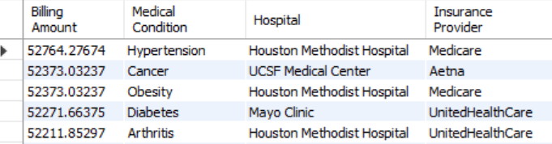

5 -- Which hospitals are treating the most patients, and how do they compare in terms of patient outcomes, like test results

elect Hospital,count(`Patient ID`) as no_patient, `Test Results`

from healthcare

group by Hospital,`Test Results`

order by no_patient desc

limit 10;

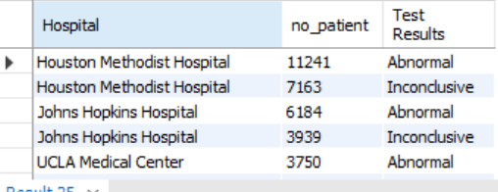

6 --What medications are most often prescribed for each condition? Are they being used consistently across hospitals

select Medication,count(*)as no_medication,`Medical Condition`,Hospital

from healthcare

group by Medication,`Medical Condition`,Hospital

order by no_medication desc



7 -- How are patients admitted—mostly through emergency, urgent, or planned admissions—and how does that impact the length of stay or treatment costs?

select

`Admission Type`,count(*) as NO_admission_Type,

AVG(DATEDIFF(`Discharge Date`, `Date of Admission`)) AS Avg_Stay_Duration,

AVG(`Billing Amount`) AS treatment_cost

from healthcare

group by `Admission Type`

order by NO_admission_Type desc,Avg_Stay_Duration desc,treatment_cost desc

limit 10;



8 -- Which insurance companies are covering the most patients, and how does that relate to treatment costs and patient outcomes?

select

`Insurance Provider`,

count(`Patient ID`) as No_patient,

AVG(`Billing Amount`) AS Avg_Cost,

MIN(`Billing Amount`) AS Min_Cost,

MAX(`Billing Amount`) AS Max_Cost,

`Test Results`

from healthcare

group by `Insurance Provider`,`Test Results`

order by No_patient desc

limit 10;

